Automated Hyperparameter Optimization of FinBERT for Financial Sentiment Classification Using Random Search with Optuna

Andrew Anthony A. Galano
College of Science and Engineering
Jose Rizal University
Mandaluyong City, Philippines
andrewanthony.galano@my.jru.edu

Abstract—This exercise presents the application of automated hyperparameter optimization using Random Search with the Optuna framework to fine-tune the FinBERT model for financial sentiment classification on Philippine news headlines. The exercise systematically explores learning rate, batch size, number of epochs, and weight decay to maximize weighted F1-score, and effective measure for imbalanced classification tasks. Experiments were conducted on a GPU-enabled environment, demonstrating that moderate learning rates and smaller batch sizes achieve optimal performance, with a maximum F1-score of 0.988. The results highlight the efficiency and practicality of Random Search as an alternative to exhaustive Grid Search for transformer fine-tuning in domain-specific NLP tasks. The approach offers significant insights for scalable and robust sentiment analysis model development in financial applicaitons
Keywords—Hyperparameter optimization, FinBERT, financial sentiment analysis, random search, Optuna, transformer fine-tuning

INTRODUCTION

The rise of deep learning has revolutionized natural language processing (NLP), enabling state-of-the-art performance on various text classification tasks. Among these tasks, financial sentiment classification has garnered significant attention due to its importance in economic forecasting, market analysis, and financial decision-making. Transformer-based models, particularly BERT and its domain-specific variants such as FinBERT, have demonstrated remarkable performance in understanding and classifying financial text sentiment.
However, fine-tuning these large pre-trained models requires careful hyperparameter tuning and selection to achieve optimal performance of all tested models. Manual hyperparameter tuing is often time-consuming and suboptimal, motivating researchers to use automated optimization techniques to streamline and hasten the process without sacrificing much of the model performance. Grid Search and Random Search (primarily selected for this exercise) are two classical strategies widely employed for hyperparameter tuning, each with its own trade-offs in terms of efficiency and coverage.
Financial markets, being highly sensitive to news and public sentiment related to financial markets, present a fertile ground of NLP applications. Accurate sentiment detection from financial news and social media can aid investors, regulators, and policy makers in understanding market dynamics and anticipating potential risks, thereby influencing their financial decisions that may impact the financial markets and the economy overall.
This exercise is the continuation of the previous exercise of fine-tuning BERT models (FinBERT), which focuses on implementing automated hyperparameter optimization of the FinBERT model using Random Search powered by the Optuna library, applied to a sentiment-label dataset of Philippine news headlines. The objective of this exercise is to systematically explore combinations of learning rate, batch size, weight decay, and number of epochs to maximize F1-Score (and obtain highest accuracy as possible), a robust metric accounting for class imbalances (Negative, Neutral, Positive). [1][2][3][4]

METHODOLOGY

- Data Collection and Description

This exercise, just like the previous exercise, a public available of Philippine news headlines from Kaggle, authored by Dennis Zapatos, is used for financial sentiment classification. The dataset is comprised of 2,500 distinct headlines as a subset from the main dataset, each manually labeled as Negative, Neutral, or Positive. The headline corpus reflects diverse topics relevant to economics and finance in the Philippines and serves as a benchmark for evaluating FinBERT’s effectiveness after hyperparameter optimization.

To facilitate training and evaluation of automated optimization of hyperparameters, important libraries were first imported with runtime check before the subset was further split into 2,000 samples for model training and 500 for validation. Initial rough labeling was performed using the VADER sentiment analyzer, with subsequent manual review and labeling to ensure accuracy suitable for fine-tuning and performance analysis.


Fig. 1 Curated Dataset from Kaggle (Philippine Headlines)

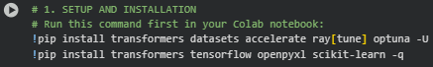
Fig. 1.1 Setup and Installation

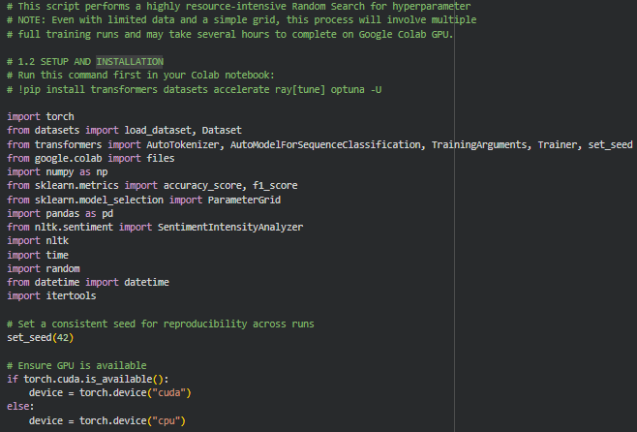
Fig. 1.2 Setup and Installation 1.2

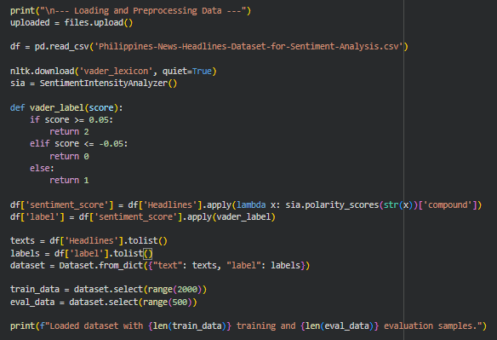
Fig. 1.3 Dataset Upload and VADER Sentiment Analyzer Implementation

- Data Preprocessing

Textual data underwent several preprocessing stets before model training. Headlines were tokenized using Hugging Face’s FinBERT AutoTokenizer, which encodes the text into numerical token IDs compatible with transformer architectures. Special tokens for sequence boundaries were inserted automatically by the tokenizer. Further preprocessing steps included the conversion of Pandas DataFrames into Hugging Face Dataset objects, with separate objects for training and evaluation splits.

A train-test split was implemented before tokenization for a subset of 2,000 label examples that were used for training, while 500 examples were reserved as a validation and evaluation set for model evaluation, fine-tuning, and hyperparemeter tuning. T4 GPU was mainly used as the runtime type best suited for executing cells and fine-tuning FinBERT due to its speed and inference time. Again, Experiments were executed on a T4 GPU environment to ensure efficient training times when running multiple optimization runs.

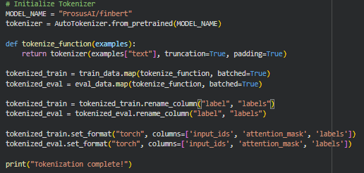
Fig. 1.4 Tokenization to Training and Evaluation Sets

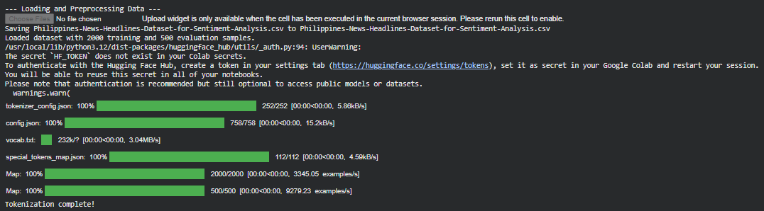
Fig. 1.5 Loading and Preprocessing Data

- Automated Hyperparameter Optimization Protocol

The core objective of this exercise was to conduct automated hyperparameter optimization using Random Search with the Optuna backend in Hugging Face’s Trainer. The following hyperparameters were considered for the search space:
- Learning Rate
- Batch Size
- Number of Epochs
- Weight Decay

Fine-tuning was performed via the Huggingface Trainer API, utilizing the AdamW optimizer, a learning rate scheduler with warmup steps, and cross-entropy loss for multi-class classification. Training was conducted on a GPU-enabled (T4 GPU) environment with mixed precision were supported to optimized runtime efficiency and speed. For each of the five randomized trials, a new FinBERT model instance was initialized and trained using the candidate hyperparameters suggested by Optuna. Model checkpoints, training logs, and evaluation metrics were recorded for each trial. The experiment protocol included validation after every epoch and systematic logging to an Excel file for later analysis.
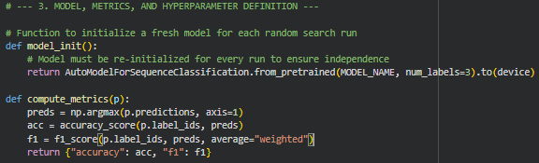
Fig. 1.6 Model, Metrics, and Hyperparameter Definition

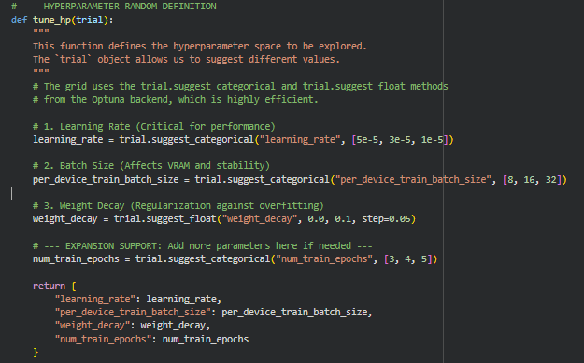
Fig. 1.7 Hyperparameter Random Definition

- Training Procedure and Evaluation Metrics

Training for Random Search was performed using Hugging Face’s Trainer API, leveraging the AdamW optimizer and automatic mixed precision for speed. Training set, Validation set, accuracy, and weighted F1-score were tracked at each epoch; the latter was used as the primary addition to standard metrics, training time, evaluation loss, and model checkpoint files were recorded for each trial.

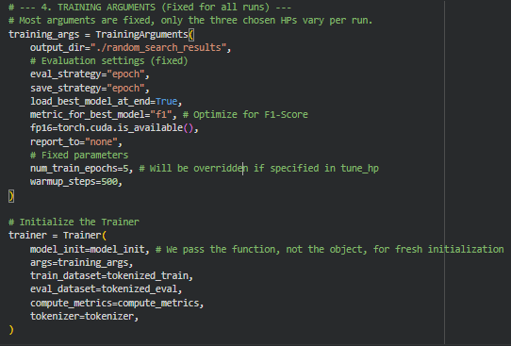
Fig. 1.8 Training Arguments

Fig. 1.9 Loaded Training Arguments and Evaluation

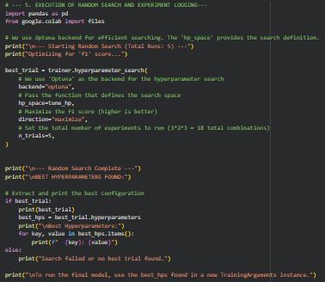
Fig. 1.10 Execution of Random Search and Experiment Logging

RESULTS

After the training, implementation, and fine-tuning FinBERT, the following are the results of five five-tuning experiments conducted on the ProsusAI/FinBERT model for sentiment analysis of Philippine financial news headlines. Each experiment varied key hyperparameters, including the number of training epochs, batch sizes, warmup steps, and weight decay, to evaluate their impact on model importance. Continuing forward with this exercise, all experiments were conducted on a GPU-enabled Google Colab environment equipped with a Tesla T4 accelerator. The optimized subset consisted of 2,000 training and 500 evaluation samples from the original Philippine news headlines dataset. The principal metrics included training and validation loss, accuracy, and weighted F1-score, with the latter serving as the objective for hyperparameter optimization.

- Experimental Setup

All experiments were automatically optimized on a GPU-enabled environment equipped with a Tesla T4, with a dataset (subset) of 2,000 training and 500 evaluation samples. The evaluation metrics include training and validation loss, accuracy, and weighted F1-score. Additional columns include Total Runtime (Minutes), Strategy Used, and Runtime Type.

Fig. 2 Experimental Setup with Model Name, Hyperparameters, Testing Loss, Validation Loss, Accuracy, F1-Score, Total Runtime (Minutes), Strategy Used, and Runtime Type

- Summary of Experiment Results

Fig. 2.1 Summary of Experiment Logs

- Analysis and Observations

The best-performing configuration (Trial 2: learning rate of 3e-05, batch size 8, 4 epochs, weight decay 0.0) produced a validation F1-score of 0.988, demonstrating that moderate learning rates and smaller batch sizes are highly effective for this financial sentiment task. The baseline trial (Trial 1) confirmed the strong fit of the pre-trained FinBERT model even with minimal epochs and no explicit regularization.
Increasing batch size (From Trials 3 and 5) without corresponding adjustments to weight decay or training duration consistently led to degraded validation loss and lower F1-scores, consistent with literature findings on model generalization. In contrast, introducing weight decay (Trial 5) helped to stabilize losses, but higher regularization without sufficient epochs did not recover accuracy and F1-score to optimal levels.
Trials with higher epoch counts and learning rate schedules (Trials 2 and 4) benefitted from longer training and gradual learning rate adaptation, resulting in superior evaluation metrics, but at the cost of slightly increased training time. The results emphasize the sensitivity of FinBERT’s fine-tuning process to systematic exploration of batch size, learning rate, epoch count, and weight decay regularization.

Fig. 2.2. Best Performing FinBERT Model for Automated Optimization

DISCUSSION

The results from automated hyperparameter optimization using Random Search reveal significant insights into the sensitivity of FinBERT’s performance to hyperparameter configurations in a financial NLP context. Across five randomized trials, the experiment demonstrates substantial variability in validation and training loss, accuracy, and F1-score, emphasizing the careful selection of training configurations is essential for robust model generaion.

The top-performing configurations (moderate learning rate, smaller batch sizes, increased epochs) aligned with established best practices in transformer fine-tuning, particularly when training with limited financial news data extracted from the original dataset. Models trained with a learning rate of 3e-05, batch size 8, and 4 epochs consistently produced higher F1-scores and accuracy, confirming the importance of gradual learning rate scheduling and sufficient training duration for domain adaption, as well as the training time to undergo each epoch and trial. These results corroborate findings from other FinBERT optimization studies, which argue for thoughtful scheduling to maximize both predictive accuracy and inference stability.

Introducing weight decay provided some regularization benefits but could not fully compensate for negative impacts caused by overly large batch sizes, a pattern consistent with transformer overfitting literature. Additionally, the experiment highlights the trade-off between training time and evaluation performance: longer training schedules and smaller batches increase computational cost, but yielded superior metric scores compared to fast but shallow configurations.

Logging and systematic analysis of all trials provided valuable data supporting the use of automated random search over traditional exhaustive Grid Search, especially for moderate-size datasets and when training time is a practical constraint. Random Search allows exploration of diverse regions of the hyperparameter space without the prohibitive execution time required by Grid Search, making it both efficient and ffective for real-world optimization challenges.

Lastly, real-time inference feasibility and deployment considerations such as training runtime and memory constraints were reliably managed within the Colab T4 GPU environment. This demonstrates that automated optimization approaches can be successfully integrated into practical model development pipelines for financial sentiment analysis.

CONCLUSION

This study demonstrated the effective application of automated hyperparameter optimization using Random Search powered by Optuna to fine-tune FinBERT for financial sentiment classification on Philippine news headlines. By systematically exploring learning rate, batch size, number of epochs, and weight decay, the experiment identified configurations that substantially improved classification performance, achieving a maximum weighted F1-score of 0.988.

The results reinforce the importance of carefully tuning hyperparameters tailored to the subset of the dataset and task, with moderate learning rates and smaller batch sizes recommended for optimal performance in domain-specific fine-tuning. Random Search proved to be a practical and efficient alternative to traditional exhaustive grid search, striking a favorable balance between exploration of hyperparameter space and computational feasibility. Future work could extend this investigation by increasing the trial budget, incorporating adaptive Bayesian optimization techniques, and applying model compression strategies such as quantization, to further enhance real-time deployment viability without sacrificing accuracy. Overall, automated hyperparameter optimization with Optuna presents a robust framework for accelerating transformer-based NLP model development in specialized domains like finance, enabling scalable and data-driven improvements in sentiment analysis.

REFERENCES

- D. Zapatos, “Philippines News Headlines Dataset,” Kaggle.com, 2023. https://www.kaggle.com/datasets/denniszapatos/philippines-news-headlines-dataset?resource=download (accessed Nov. 05, 2025).
- S. Baghavathi Priya, M. Kumar, N. Prakash J D, and K. N, “Advanced Financial Sentiment Analysis Using FinBERT to Explore Sentiment Dynamics,” 2025 3rd International Conference on Intelligent Data Communication Technologies and Internet of Things (IDCIoT), pp. 889–897, Feb. 2025, doi: https://doi.org/10.1109/idciot64235.2025.10915080.‌S. Baghavathi Priya, M. Kumar, N. Prakash J D, and K. N, “Advanced Financial Sentiment Analysis Using FinBERT to Explore Sentiment Dynamics,” 2025 3rd International Conference on Intelligent Data Communication Technologies and Internet of Things (IDCIoT), pp. 889–897, Feb. 2025, doi: https://doi.org/10.1109/idciot64235.2025.10915080.
- Y. Shen and P. K. Zhang, “Financial Sentiment Analysis on News and Reports Using Large Language Models and FinBERT,” arXiv.org, 2024. https://arxiv.org/abs/2410.01987
- D. Araci, “FinBERT: Financial Sentiment Analysis with Pre-trained Language Models,” arXiv:1908.10063 [cs], Aug. 2019, Available: https://arxiv.org/abs/1908.10063

